* **Create a user with user group**  
  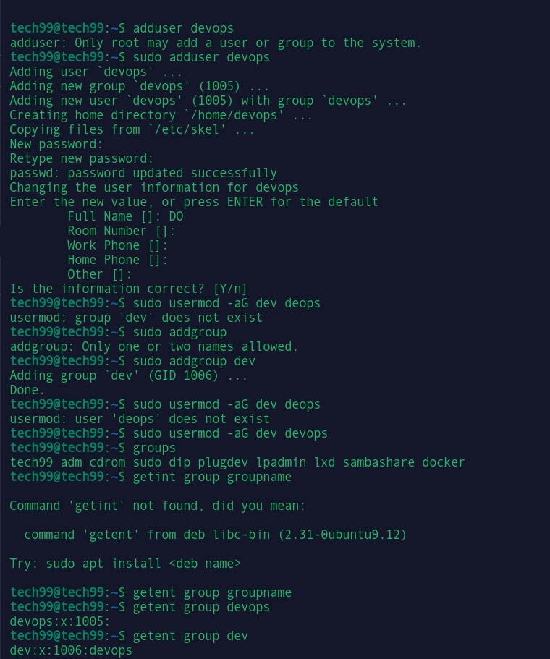
* Create two directories in user's home directory named os-concepts and ubuntu-is-the-best

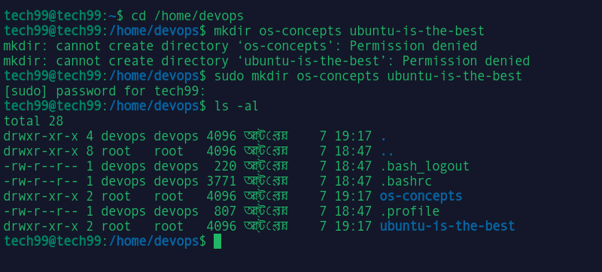

* Create two files on each directory

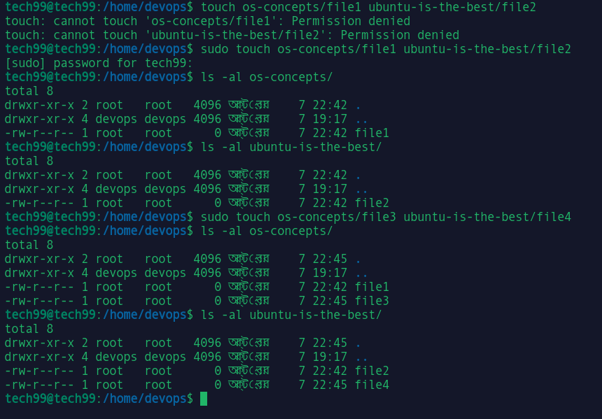

* List the files with detailed information ( including file permission )

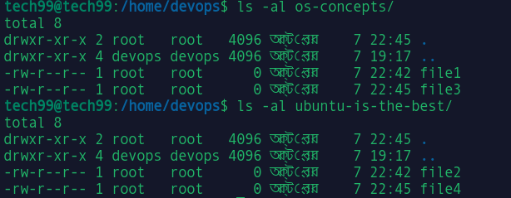

* Update file permission so that owner can read,write and group can only read and others can not do anything

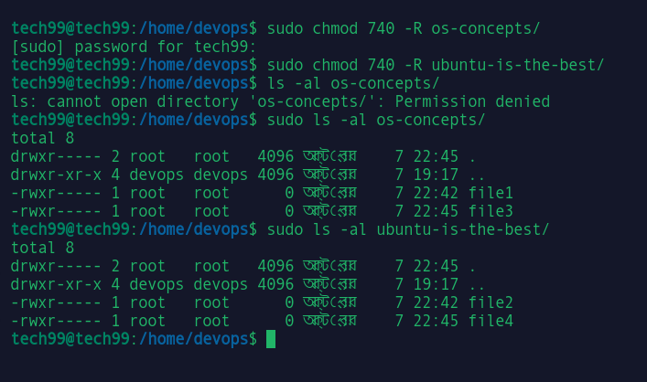

* Create another group
* Update file ownership to the newly created group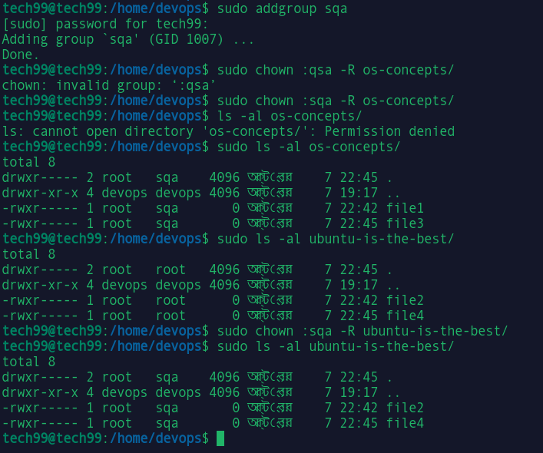
* Add the user to the new group

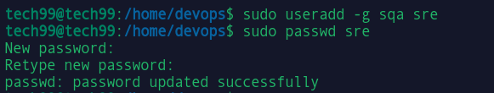

* Create a file called crash.in ( File should contain the word crash in it ) in different directories and then find the file in all the locations using find command

